**Chapter One: Introduction**

**1.1 Introduction**

The evolution of technology has significantly transformed service delivery across various industries, including hospitality. In the modern digital economy, customers expect convenience, transparency, and speed when searching and booking accommodations. This project aims to develop a Hotel Booking System with integrated customer reviews. The system enables users to view available rooms, make payments, access hotel images and location, and leave verified reviews after their stay. By incorporating real-time availability and a review mechanism, the system bridges the gap between customer expectations and hotel service delivery.

**1.2 Background of the Study**

In the past, hotel bookings were predominantly manual—through physical visits, phone calls, or travel agents. This often led to double bookings, miscommunications, and poor customer service. The rise of third-party hotel booking platforms brought some relief but introduced challenges like high commission fees, data fragmentation, and limited review authenticity. Moreover, many small to medium-sized hotels cannot afford premium listing services or systems that allow them to manage their bookings effectively.

The proposed system seeks to provide an affordable, scalable, and fully integrated platform for both customers and hotel administrators. By allowing direct hotel bookings with real-time vacancy tracking and a built-in review mechanism, it promotes customer satisfaction, hotel visibility, and service improvement.

**1.3 Problem Statement**

Most local hotels lack a reliable, user-friendly digital system for managing bookings and gathering feedback. Customers often face difficulties such as:

* Unavailable or outdated information about room availability,
* Inability to make secure online payments,
* No platform to share or read honest reviews,
* Limited access to images or location information.

These issues result in poor customer experiences, lost bookings, and damaged hotel reputations.

**1.4 Problem Solution**

This system will:

* Offer real-time room availability tracking,
* Enable secure booking and payment through integrated APIs (e.g., Stripe or Mpesa),
* Allow users to leave and read reviews for each hotel,
* Display hotel images and embed Google Maps for location context,
* Provide an admin panel for hotel managers and system administrators to monitor activity and manage listings.

**1.5 Objectives of the System**

**1.5.1 Main Objective**

To develop an intelligent hotel booking system that allows users to search for hotels, check room availability, book and pay securely, and submit reviews to improve transparency and service quality.

**1.5.2 Specific Objectives**

* To design a system that displays real-time hotel room availability.
* To allow secure payment and booking confirmation.
* To integrate a hotel review and rating module based on verified stays.
* To store and display multiple hotel images.
* To implement location tracking using address or Google Maps API.
* To develop an admin panel for hotel and booking management.

**1.6 Research Questions**

1. How can we design a system that accurately shows hotel room availability in real time?
2. What technologies can be used to ensure secure and traceable online payments?
3. How can we verify and display hotel reviews to increase customer trust?
4. What interface features will best showcase hotel images and locations to attract customers?
5. How can administrators effectively manage bookings, reviews, and hotel data?

**1.7 Scope of the Study**

This project focuses on developing a web-based hotel booking platform. It will cover:

* User registration and login
* Hotel and room listings with images
* Booking and payment functionality
* Review and rating module
* Admin dashboard
* The project will not include a mobile app (although the system will be mobile-responsive).

**1.8 Justification**

The solution is essential for digitizing hotel operations, especially for small-to-mid-sized hotels without access to expensive third-party tools. By improving customer access to accurate booking information, promoting genuine feedback, and facilitating payments, this system enhances overall user experience, hotel service quality, and business operations.

**1.9 Risks and Mitigation**

The development and deployment of a web-based hotel booking system involve several risks. Identifying these risks early and applying appropriate mitigation strategies is critical for project success.

| **Risk** | **Mitigation Strategy** |  |
| --- | --- | --- |
| **Payment failure or fraud** | Use secure, tested APIs like Stripe/PayPal or Mpesa; implement HTTPS and encrypt all payment transactions. |  |
| **Spam or fake reviews** | Allow only users with verified bookings to leave reviews; apply CAPTCHA and review moderation. |
| **Unauthorized access or data breach** | Implement strong user authentication (e.g., hashed passwords, sessions), and role-based access control. |  |
| **Double booking due to concurrency issues** | Lock booking slots during the payment process; update room availability in real-time. |  |
| **Server or hosting failure** | Use cloud-based or redundant hosting solutions with regular backups. |  |
| **Loss of uploaded hotel images** | Store uploaded images in a secure cloud storage like Cloudinary or AWS S3, with backup configuration. |
| **Low system adoption by hotels or users** | Create a user-friendly interface and offer tutorials or documentation; integrate local payment options. |  |
| **System bugs or technical failure** | Conduct rigorous testing (unit, integration, UAT); have a test environment before deployment. |  |
| **Internet dependency in remote areas** | Ensure the system is lightweight, cache critical data locally, and make it mobile-responsive. |  |

**1.10 System Requirements**

**Hardware Requirements**

* A standard laptop or server with:
  + Minimum 8 GB RAM
  + 500 GB storage
  + Internet connectivity

**Software Requirements**

* **Backend**: Node.js , MongoDB ,Express(MEN)
* **Frontend**: HTML, CSS, JavaScript
* **Database**: MySQL /MongoDB
* **Payment Gateway**: Stripe / Mpesa Sandbox
* **APIs**: Google Maps API
* **Tools**: VS Code, XAMPP, GitHub, Postman

**1.11 Budget**

| **Item** | **Estimated Cost** |
| --- | --- |
| Hosting (1 year) | KES 3,000 |
| Domain Registration | KES 1,500 |
| Internet Bundles | KES 2,000 |
| Misc (transport, testing) | KES 1,000 |
| **Total** | **KES 7,500** |

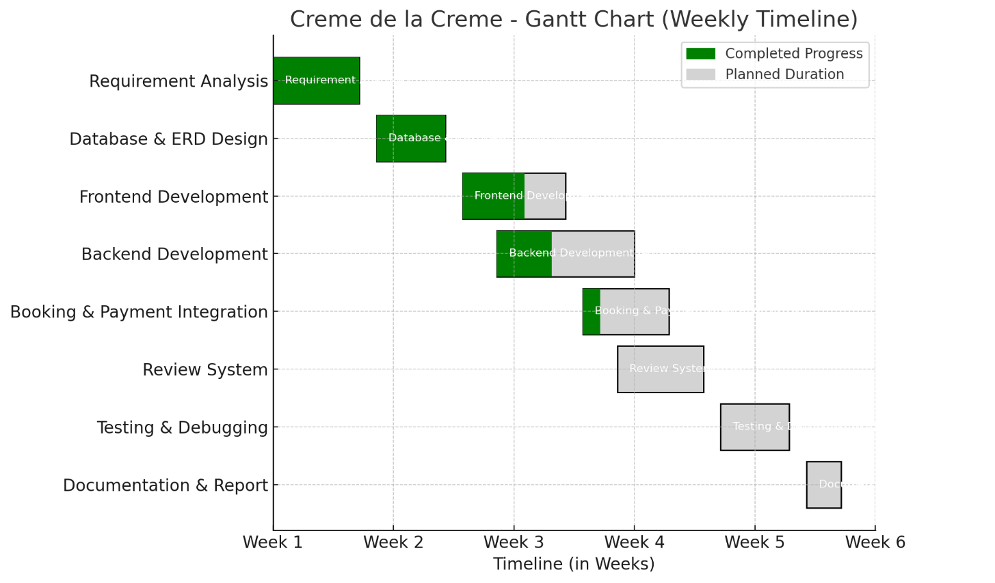

**GANTT CHART**

**Chapter Two: Literature Review**

**2.1 Past Information**

The growth of digital hotel booking platforms has significantly transformed the hospitality industry. Systems such as Booking.com and Airbnb have simplified the booking process, offering users access to a wide range of hotels, apartments, and services globally. These platforms allow customers to make reservations, view hotel amenities, and read reviews from past guests (Smith, 2018).

However, these platforms present challenges. Many local hotels in developing regions struggle with the high commission fees, lack of localization, and minimal customization options (Mugo, 2020). Additionally, while reviews exist, the credibility of these reviews is often questioned, as some platforms allow reviews from users who may not have actually stayed at the hotel (Ngugi, 2019).

Recent literature also notes the importance of verified feedback and user-friendly interfaces. Studies show that most customers trust reviews only if they come from verified bookings (Kariuki & Odhiambo, 2022). There is a need for systems that directly link bookings with user reviews to ensure authenticity and improve decision-making.

Furthermore, localized payment solutions like Mpesa in Kenya have become critical to digital service adoption. Integrating such payment options can significantly increase usability and trust among users in the African region (Wanjala, 2021).

**2.2 Additions of Knowledge**

* **Mugo (2020)** highlighted how many hotel owners rely on manual systems or global platforms that don't support local languages or payment options.
* **Ngugi (2019)** emphasized the growing concern over fake reviews and how they negatively affect consumer trust in digital platforms.
* **Kariuki and Odhiambo (2022)** advocated for systems that ensure only verified guests can leave reviews and suggested simplified admin panels for hotel owners.
* **Wanjala (2021)** explored the role of mobile money (e.g., Mpesa) in boosting online commerce in Kenya, especially in the hospitality sector.
* **Smith (2018)** provided a comprehensive analysis of features found in international platforms like Booking.com, praising their scalability but acknowledging their lack of localization.

**2.3 Criticism and Comparisons**

| **System** | **Strengths** | **Weaknesses** |
| --- | --- | --- |
| Booking.com | Global reach, rich user interface | High fees, no Mpesa, reviews can be manipulated |
| Hotelogix | Robust cloud-based hotel management | Not user-focused, technical complexity |
| Proposed System | Verified reviews, local payment support | Currently web-only (no mobile app), basic admin tools |

The proposed system stands out by offering features relevant to the local market: integration with local payment gateways, verified review submission, and simplified booking flow. It is designed with affordability, transparency, and usability in mind, especially for small and medium-sized hotels.

**References**

* Kariuki, P., & Odhiambo, S. (2022). *Trust Mechanisms in Local Hotel Booking Systems*. Journal of African ICT Studies, 14(2), 112-119.
* Mugo, L. (2020). *Digitizing Hospitality in Kenya: Opportunities and Challenges*. Nairobi: Kenya Tech Press.
* Ngugi, M. (2019). *Customer Trust and Fake Reviews in Online Booking Platforms*. Journal of Digital Consumer Behavior, 7(4), 215–223.
* Smith, J. (2018). *Global Online Booking Platforms: Impact and Design*. International Journal of Web Applications, 22(1), 45–60.
* Wanjala, T. (2021). *The Role of Mpesa in Supporting E-Commerce Adoption in Kenya*. African Journal of FinTech Innovation, 9(1), 55–63.